Kubernetes Task-09
1.Execute all the steps shown in video.
Upgrade k8s cluster from 1.29 to 1.30 Version. Note: Document to upgrade cluster.https://devopscube.com/upgrade-kubernetes-cluster-kubeadm/
- Check current version
Run on master:
kubectl get nodes
kubeadm version
kubectl version
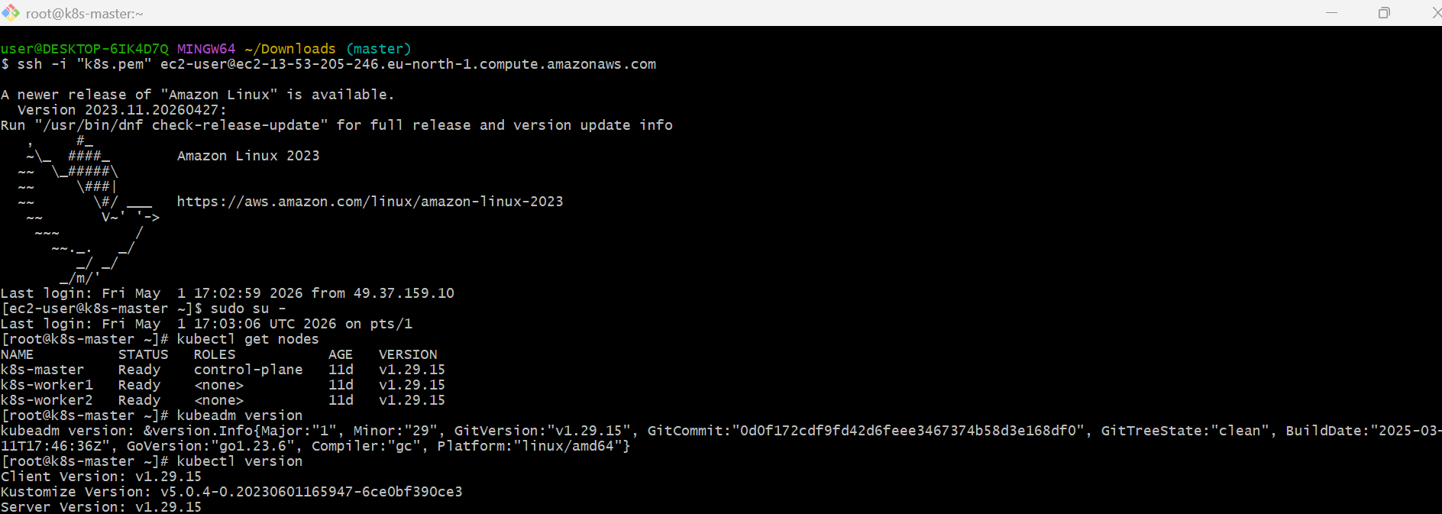
I currently have:
Client Version: v1.29.15
Server Version: v1.29.15
- On master: change Kubernetes repo to v1.30
cat <<EOF | sudo tee /etc/yum.repos.d/kubernetes.repo
[kubernetes]
name=Kubernetes
baseurl=https://pkgs.k8s.io/core:/stable:/v1.30/rpm/
enabled=1
gpgcheck=1
gpgkey=https://pkgs.k8s.io/core:/stable:/v1.30/rpm/repodata/repomd.xml.key
exclude=kubelet kubeadm kubectl cri-tools kubernetes-cni
EOF
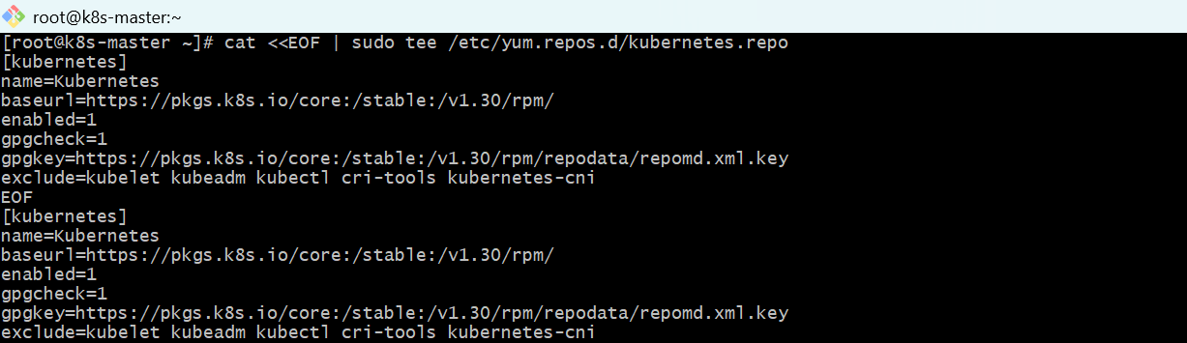
- Upgrade kubeadm on master
sudo dnf clean all
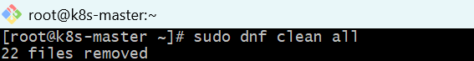
sudo dnf list --showduplicates kubeadm --disableexcludes=Kubernetes
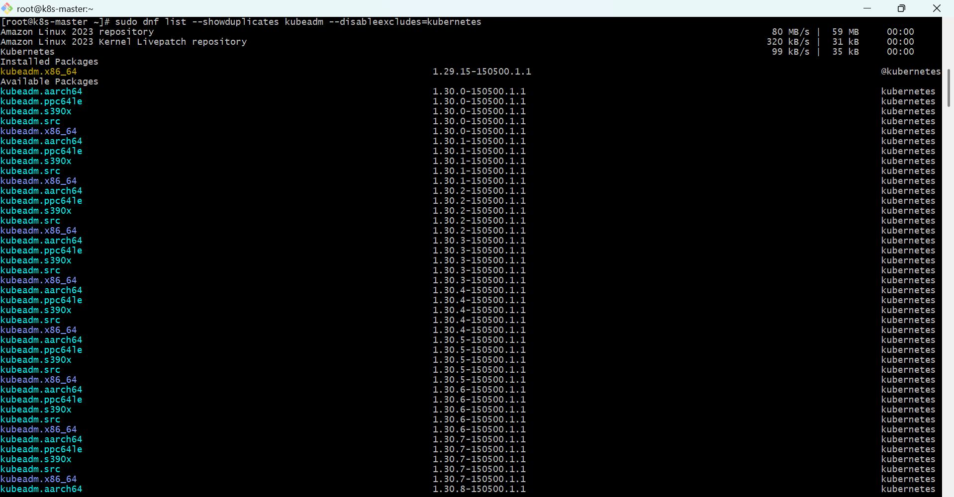
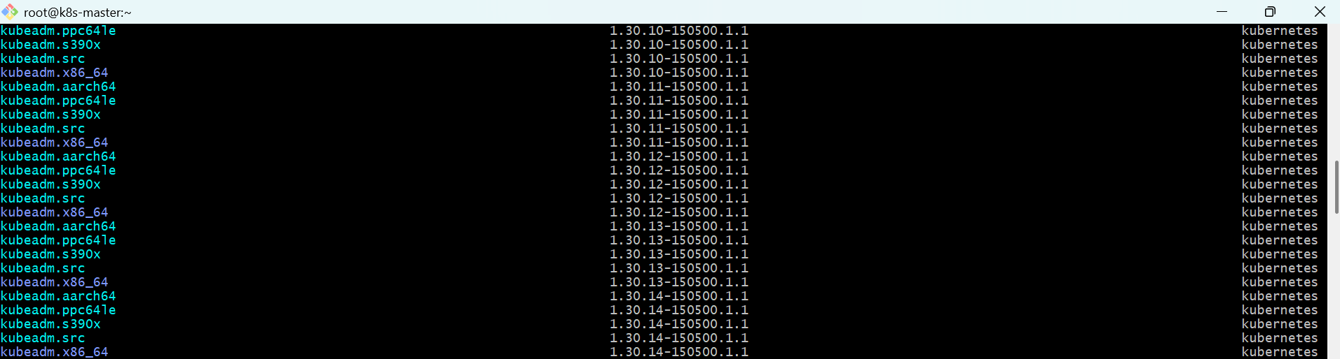

sudo dnf install -y kubeadm-1.30.14 --disableexcludes=Kubernetes
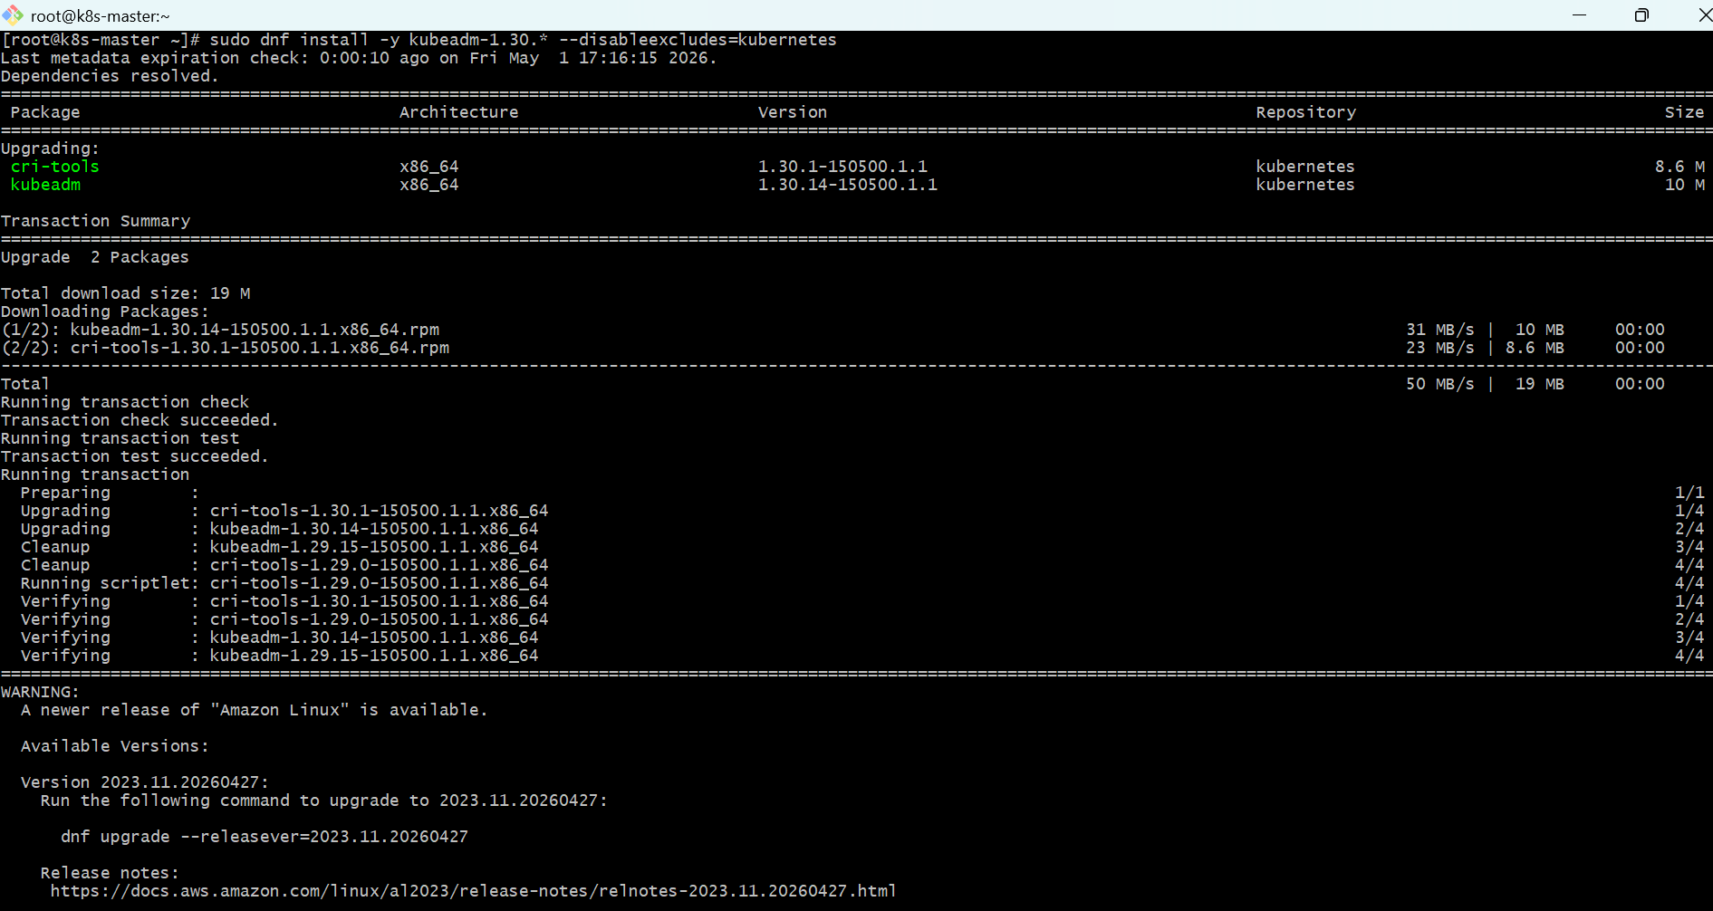
- Check:
kubeadm version
- Plan upgrade
sudo kubeadm upgrade plan
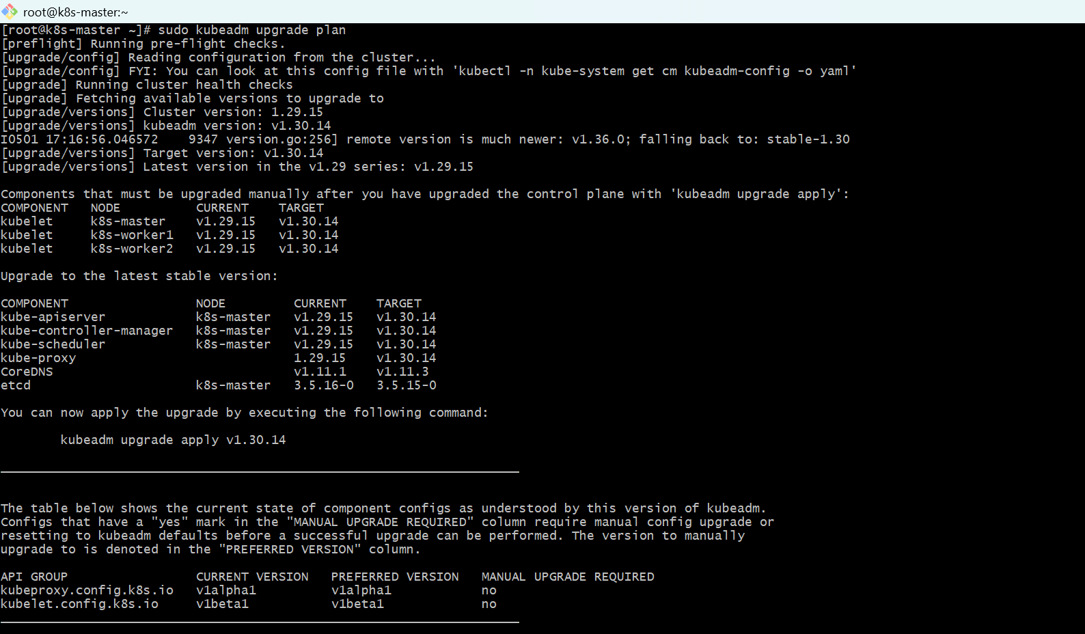
- Then apply upgrade:
sudo kubeadm upgrade apply v1.30.14
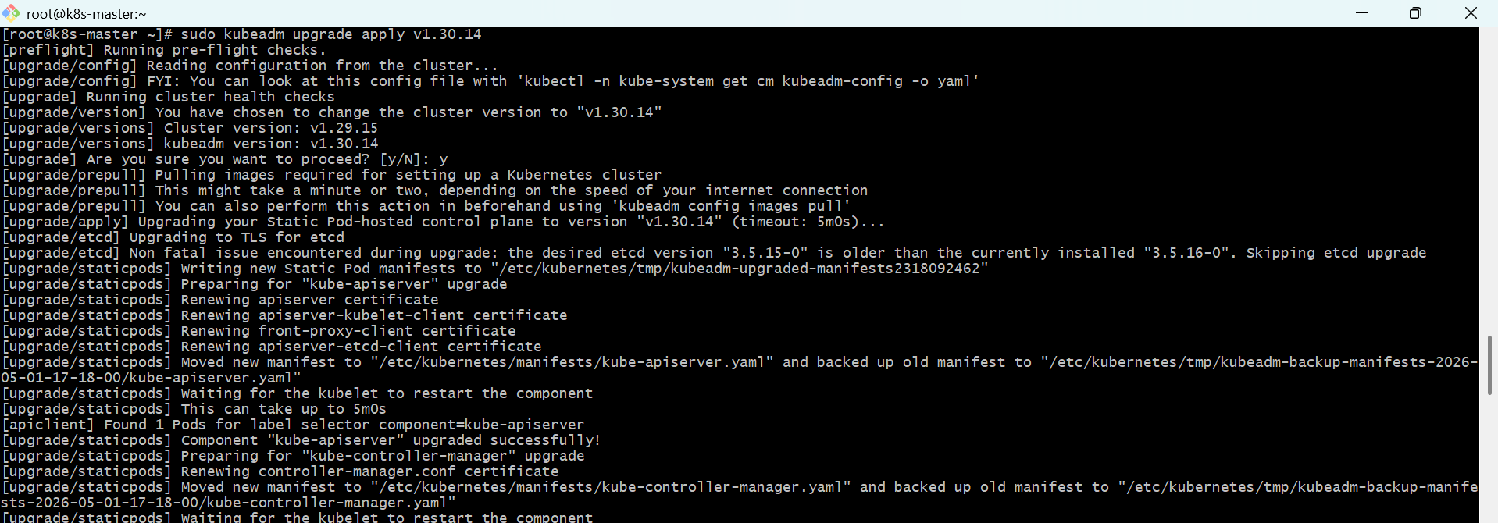
- Drain master node
First check node name:
kubectl get nodes
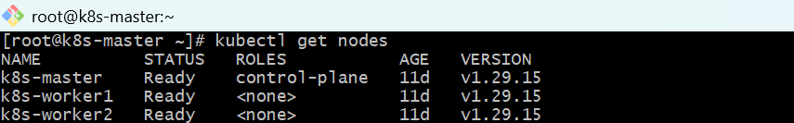
- Drain master:
kubectl drain k8s-master --ignore-daemonsets --delete-emptydir-data
- Upgrade kubelet and kubectl on master
sudo dnf install -y kubelet-1.30.14 kubectl-1.30.14 --disableexcludes=kubernetes
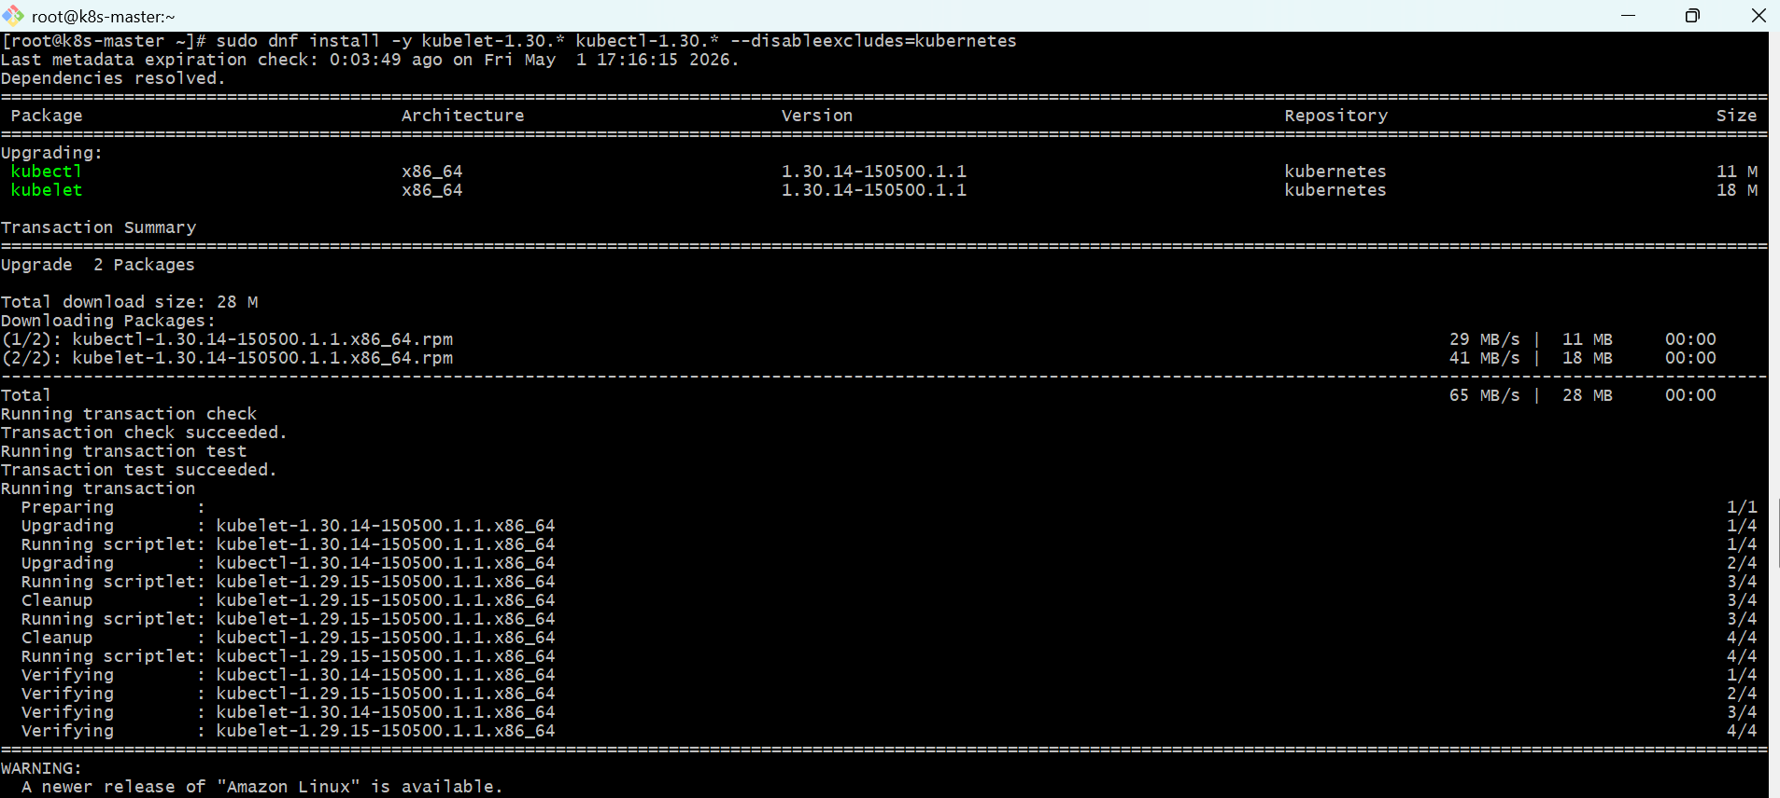
sudo systemctl daemon-reload
sudo systemctl restart kubelet
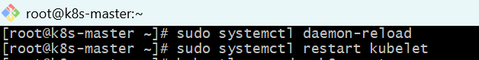
- Uncordon master:
kubectl uncordon k8s-master
- Check:
kubectl get nodes
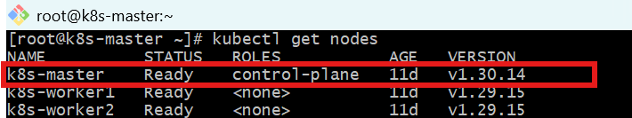
kubectl version
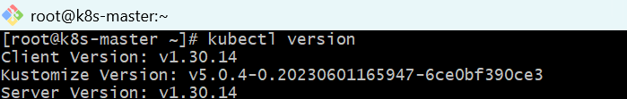
- Worker nodes upgrade
- On k8s-worker1: update repo to v1.30
cat <<EOF | sudo tee /etc/yum.repos.d/kubernetes.repo
[kubernetes]
name=Kubernetes
baseurl=https://pkgs.k8s.io/core:/stable:/v1.30/rpm/
enabled=1
gpgcheck=1
gpgkey=https://pkgs.k8s.io/core:/stable:/v1.30/rpm/repodata/repomd.xml.key
exclude=kubelet kubeadm kubectl cri-tools kubernetes-cni
EOF
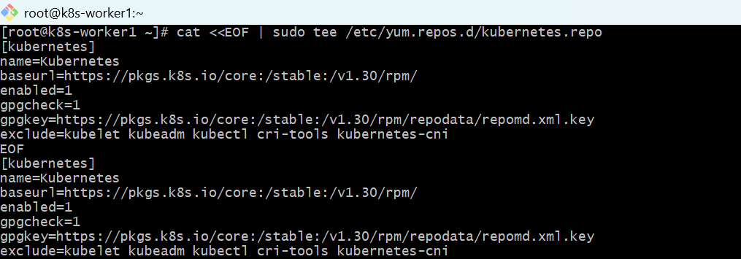
- On k8s-worker1: upgrade kubeadm
sudo dnf clean all
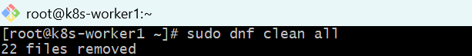
sudo dnf install -y kubeadm-1.30.14 --disableexcludes=kubernetes
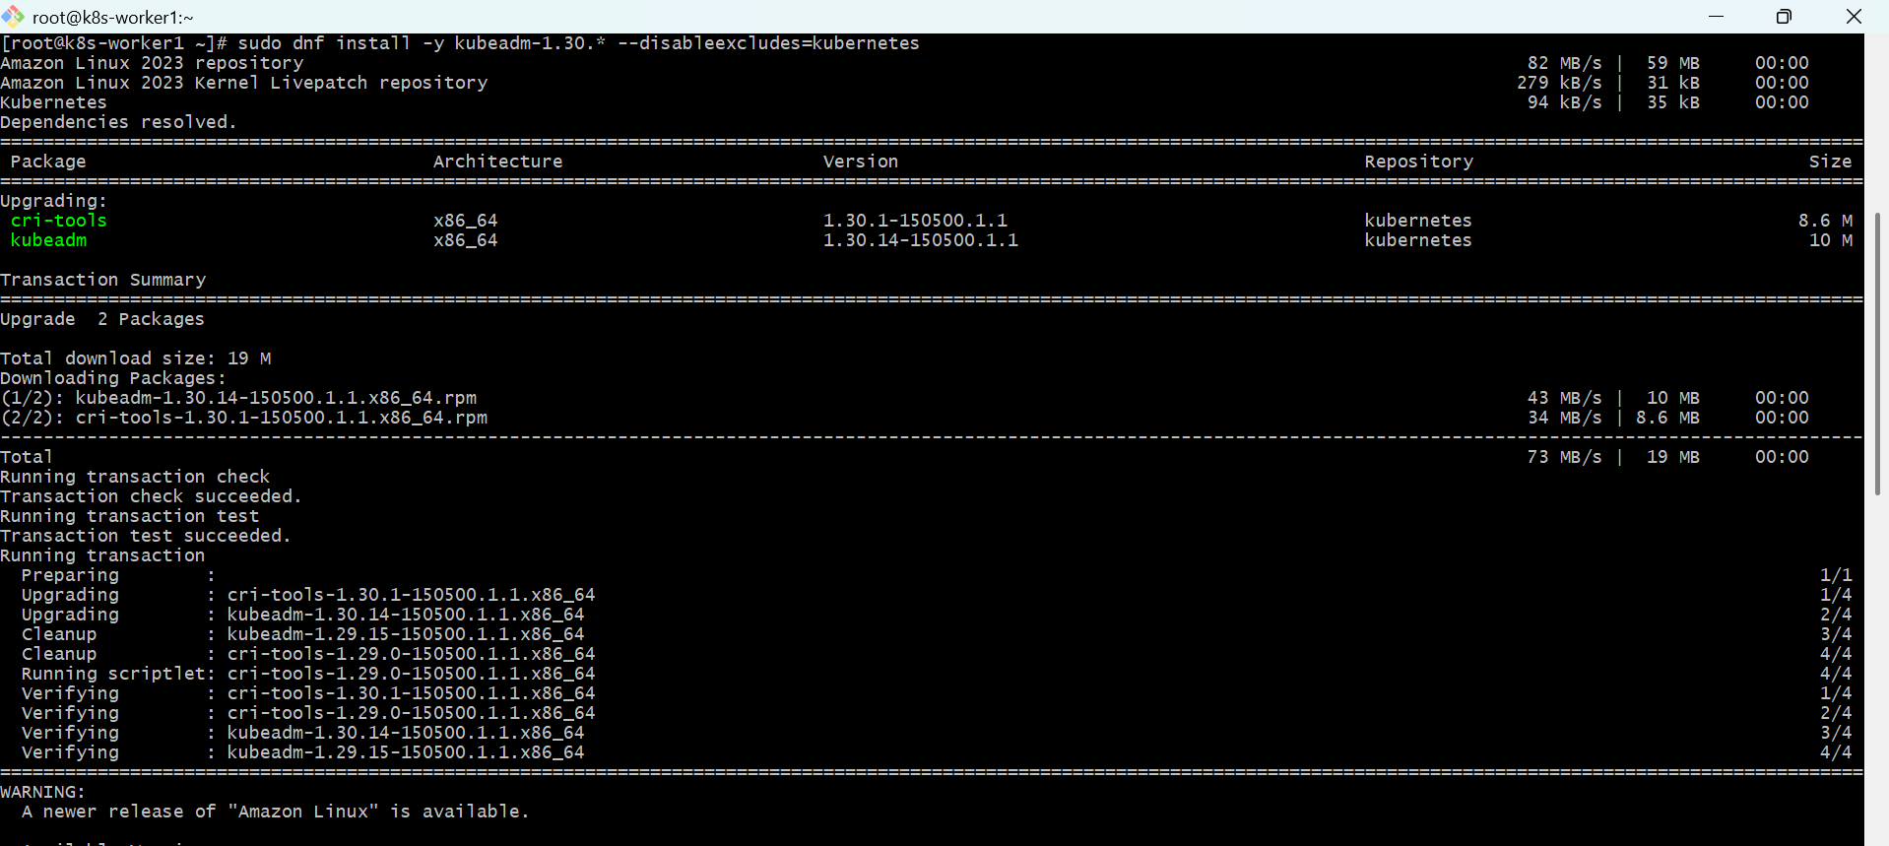
- Run:
sudo kubeadm upgrade node
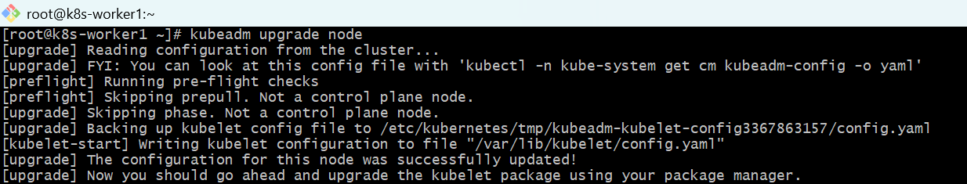
- From master: drain worker
kubectl drain k8s-worker1 --ignore-daemonsets --delete-emptydir-data
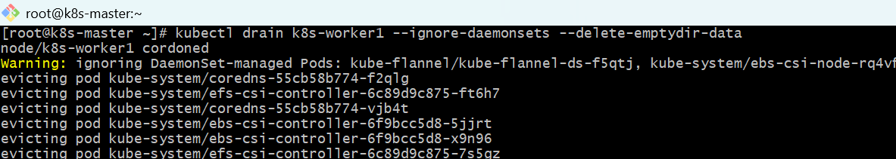
- On worker: upgrade kubelet and kubectl
sudo dnf install -y kubelet-1.30.* kubectl-1.30.* --disableexcludes=Kubernetes
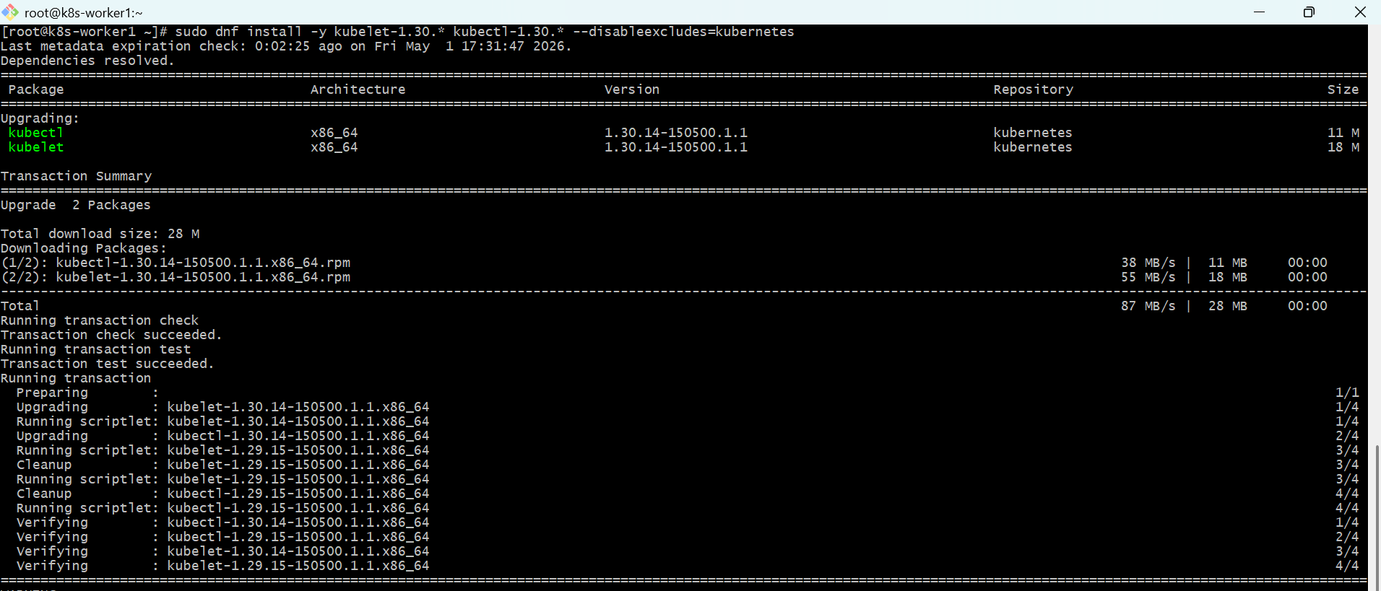
sudo systemctl daemon-reload
sudo systemctl restart kubelet
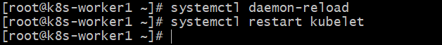
- From master: uncordon worker
kubectl uncordon k8s-worker1
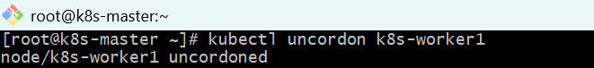
- On k8s-worker2: update repo to v1.30
cat <<EOF | sudo tee /etc/yum.repos.d/kubernetes.repo
[kubernetes]
name=Kubernetes
baseurl=https://pkgs.k8s.io/core:/stable:/v1.30/rpm/
enabled=1
gpgcheck=1
gpgkey=https://pkgs.k8s.io/core:/stable:/v1.30/rpm/repodata/repomd.xml.key
exclude=kubelet kubeadm kubectl cri-tools kubernetes-cni
EOF
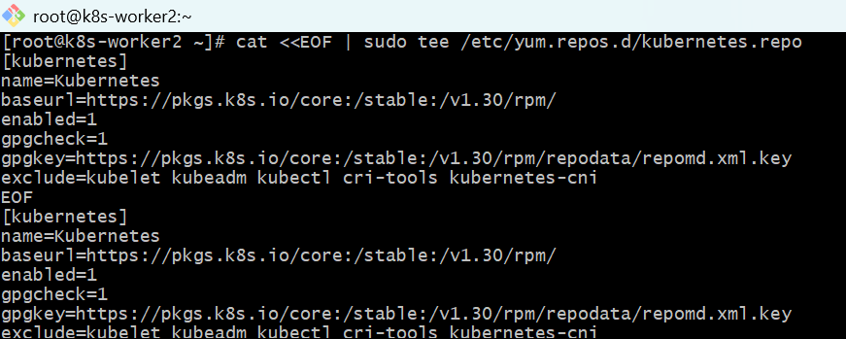
- On worker: upgrade kubeadm
sudo dnf clean all
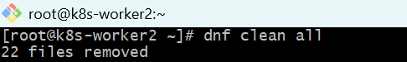
sudo dnf install -y kubeadm-1.30.14 --disableexcludes=Kubernetes
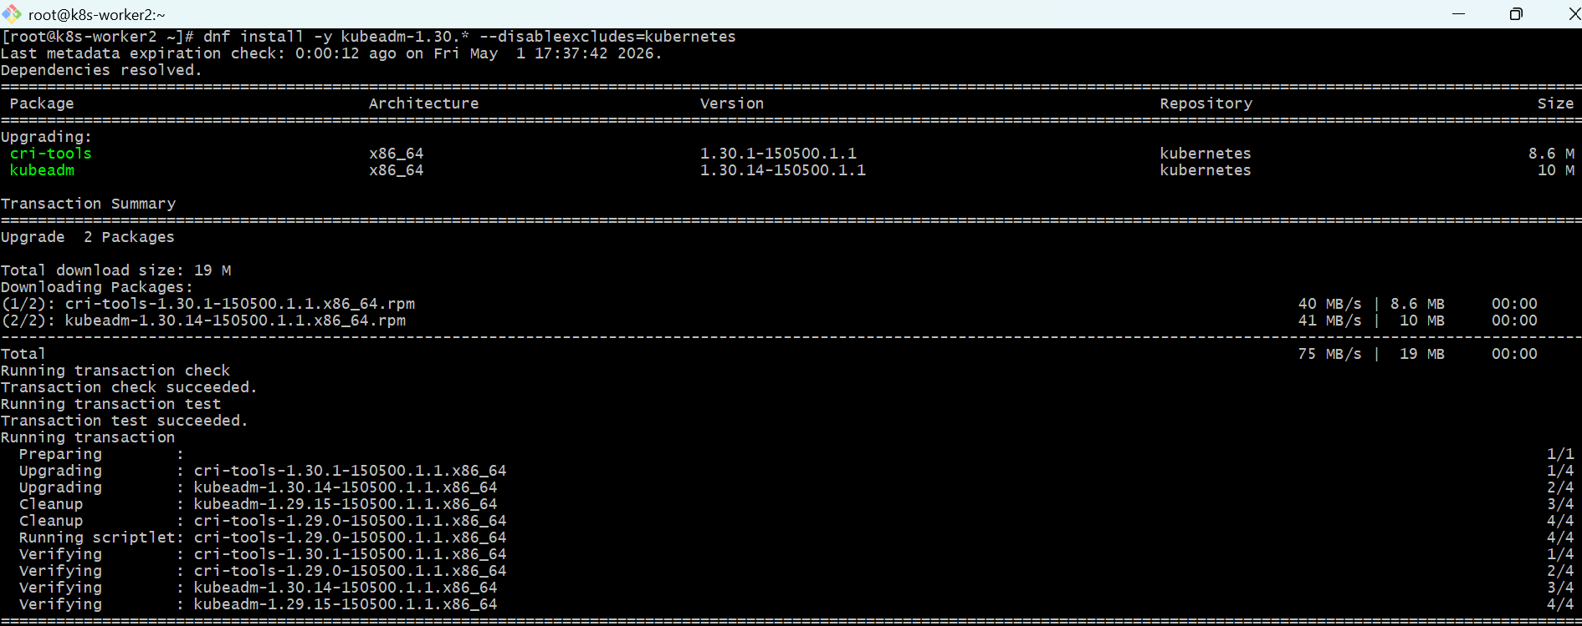
- Run:
sudo kubeadm upgrade node
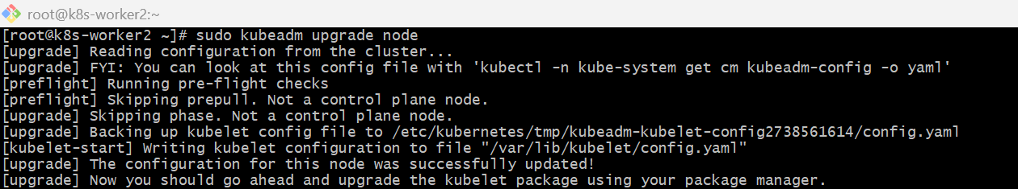
- From master: drain worker
kubectl drain k8s-worker2 --ignore-daemonsets --delete-emptydir-data
- On worker: upgrade kubelet and kubectl
sudo dnf install -y kubelet-1.30.14 kubectl-1.30.14 --disableexcludes=Kubernetes
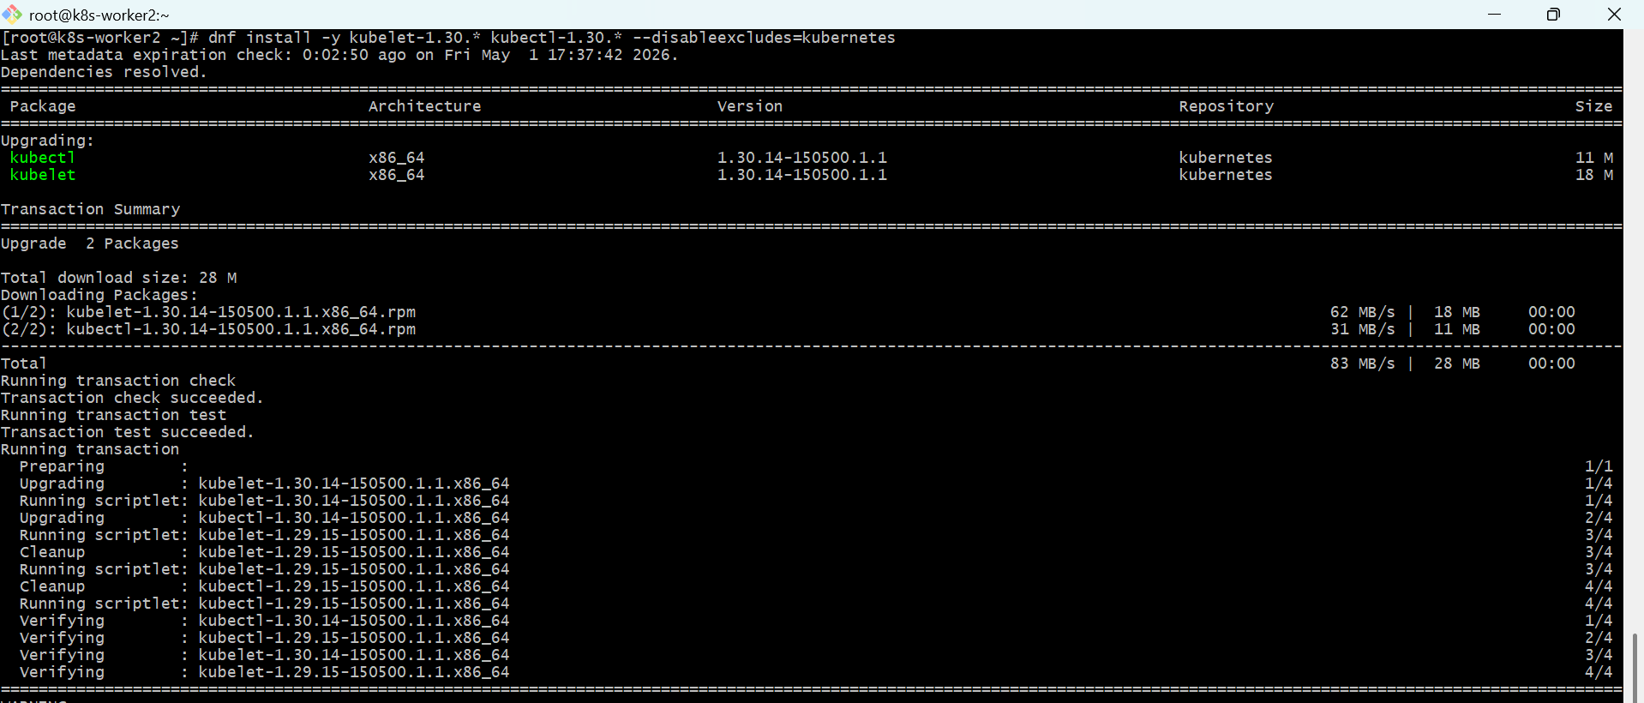
sudo systemctl daemon-reload
sudo systemctl restart kubelet
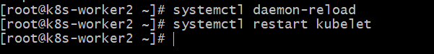
- From master: uncordon worker
kubectl uncordon k8s-worker2

- Final verification
Run on master:
kubectl get nodes
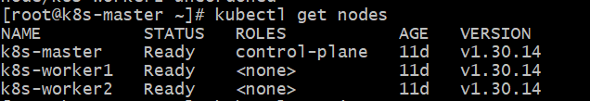
kubectl version
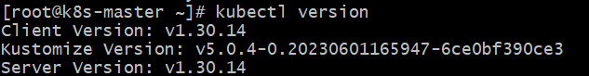

kubectl get pods -A
